**AIT-524, Class 14, Practice Problems**

**Tanmoy Chowdhury, G01025893**

### Practice Problems:

**Questions:**

To perform the following assignments, refer to the tables in the JustLee Books database.  
**1. Create a view that lists the name and phone number of the contact person at each publisher. Don’t include the publisher’s ID in the view. Name the view CONTACT.**

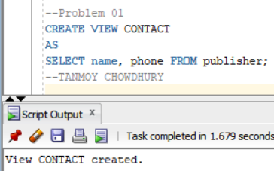

**2. Change the CONTACT view so that no users can accidentally perform DML operations on the view.**

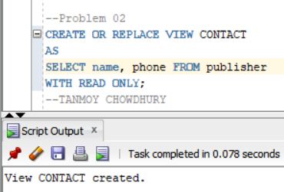

**3. Create a view called HOMEWORK13 that includes the columns named Col1 and Col2 from the FIRSTATTEMPT table. Make sure the view is created even if the FIRSTATTEMPT table doesn’t exist.**

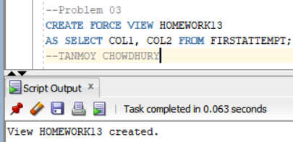

**4. Attempt to view the structure of the HOMEWORK13 view.**

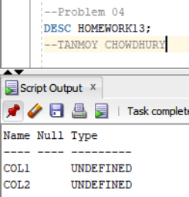

**5. Create a view that lists the ISBN and title for each book in inventory along with the name and phone number of the person to contact if the book needs to be reordered. Name the view REORDERINFO.**

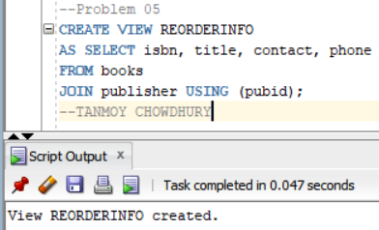

**6. Try to change the name of a contact person in the REORDERINFO view to your name. Was an error message displayed when performing this step? If so, what was the cause of the error message?**

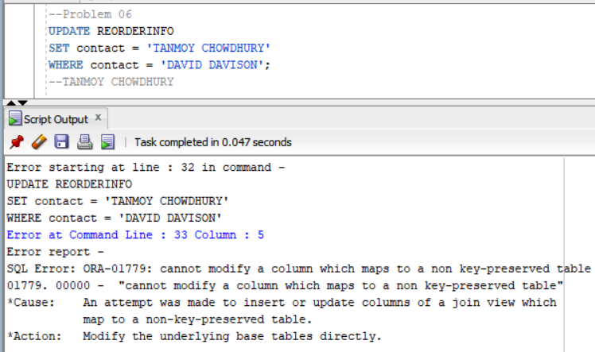

**Explanation**: The primary key for the PUBLISHER table isn’t in the view. So, This command doesn’t execute.

**7. Select one of the books in the REORDERINFO view and try to change its ISBN. Was an error message displayed when performing this step? If so, what was the cause of the error message?**

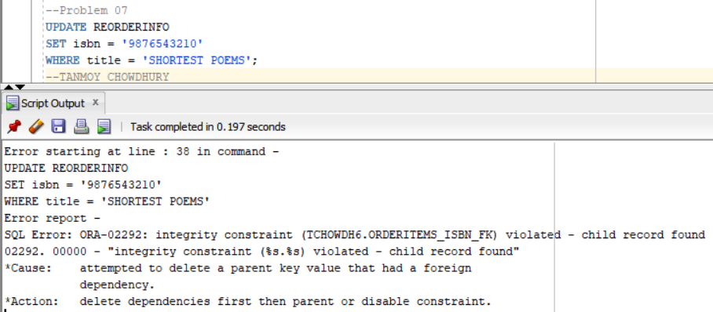

**Explanation**: This command fails because of constraint violations. Consider all the FOREIGN KEY constraints involving the BOOKS table, including the relationship with the ORDERITEMS and PUBLISHER tables. If this statement didn’t violate any FOREIGN KEY contraints, it would execute successfully because the primary key of BOOKS is included in the view.

**8. Delete the record in the REORDERINFO view containing your name. (If you weren’t able to perform #6 successfully, delete one of the contacts already listed in the table.) Was an error message displayed when performing this step? If so, what was the cause of the error message?**

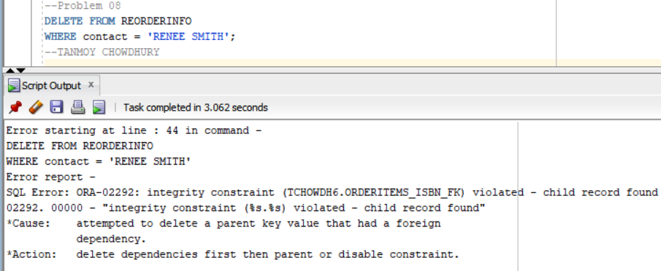

**Explanation**: This command attempts to delete rows from the BOOKS table and fails because of FOREIGN KEY constraint violations. If this statement didn’t violate any constraints, rows from the BOOKS table would be deleted because ISBN is considered the view’s primary key.

**9. Issue a rollback command to undo any changes made with the preceding DML operations.**

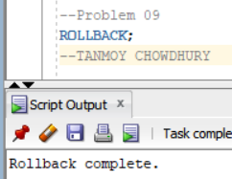

**10. Delete the REORDERINFO view**

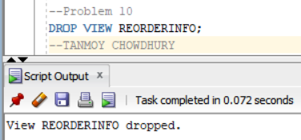

**CHAPTER 6:**

**1. Create a sequence for populating the Customer# column of the CUSTOMERS table. When setting the start and increment values, keep in mind that data already exists in this table. The options should be set to not cycle the values and not cache any values, and no minimum or maximum values should be declared.**

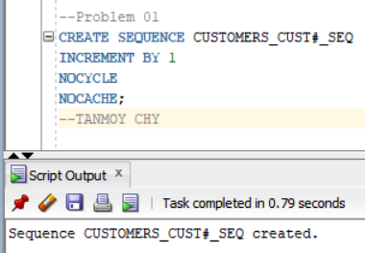

**2. Add a new customer row by using the sequence created in Question 1. The only data currently available for the customer is as follows: last name = Shoulders, first name = Frank, and zip = 23567.**

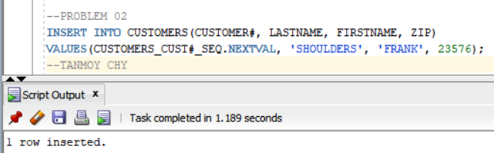

**3. Create a sequence that generates integers starting with the value 5. Each value should be three less than the previous value generated. The lowest possible value should be 0, and the sequence shouldn’t be allowed to cycle. Name the sequence MY_FIRST_SEQ.**

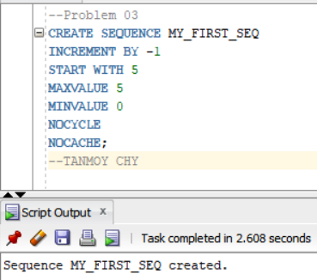

**4. Issue a SELECT statement that displays NEXTVAL for MY_FIRST_SEQ three times. Because the value isn’t being placed in a table, use the DUAL table in the FROM clause ofthe SELECT statement. What causes the error on the third SELECT?**

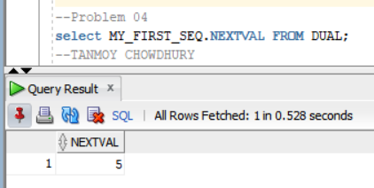

**5. Change**

